**Daily Scrum or Standup Meeting**

Team name: 5th Element

Scrum Master: Leonardo Craven

Date: October 27, 2021

| **Team Member** | **What did you do since the last scrum?** | **What do you plan to do before the next scrum?** | **What obstacles do you have?** |
| --- | --- | --- | --- |
| Leo | Finished archived tournaments page, finished adding CSS to previously worked pages | Update documentation to reflect all changes | None |
| Gavin | Worked on adding CSS to pages, worked on tournament deletion | Finish adding CSS to previously worked pages | None |
| Andrew | Nothing (trying to setup work laptop after account wiped) | Add page for sponsors to sponsor existing tournaments | Getting laptop set back up |
| Brock | Finished user type management page, worked on registered tournaments page | Add CSS to previously worked pages, finish registered tournaments page | Midterms |

# Burndown

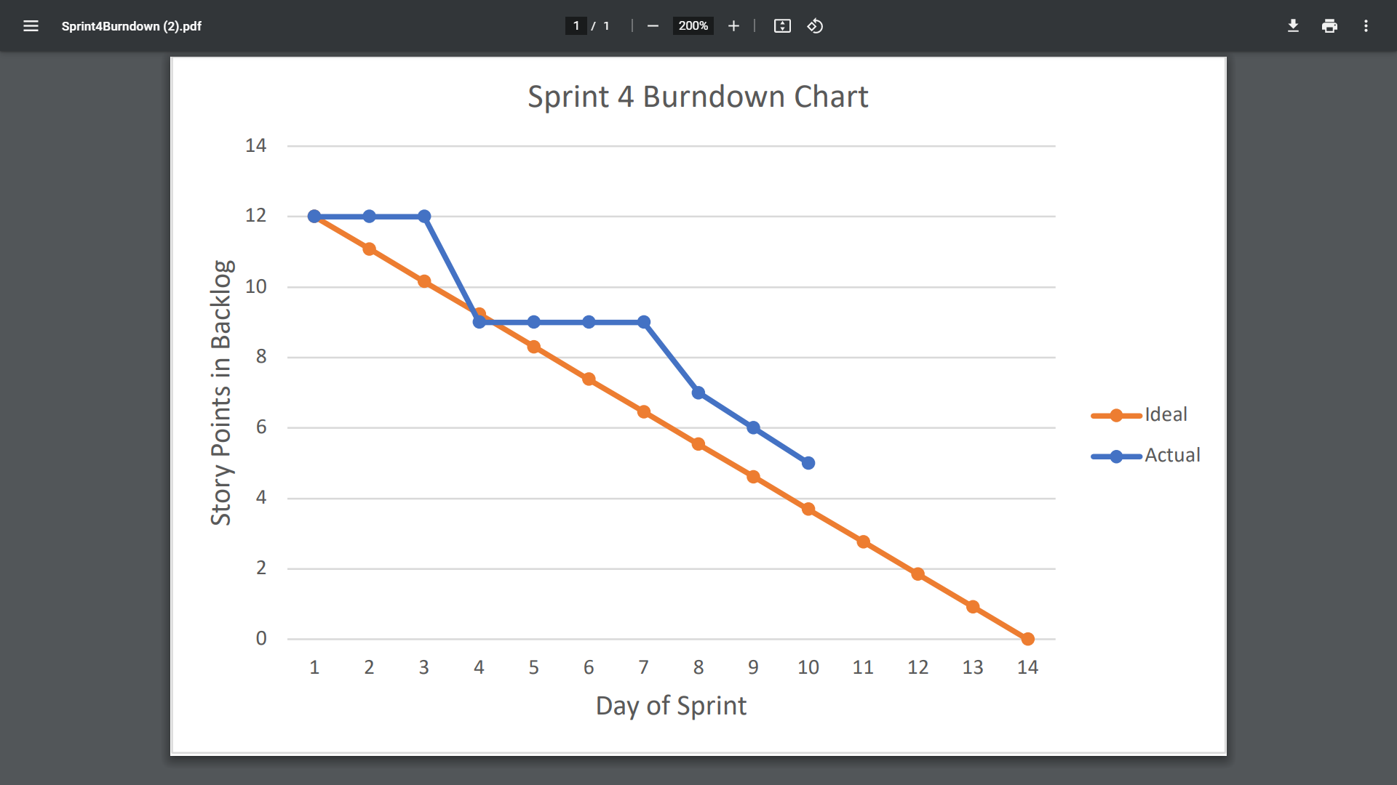

# Screenshot of you project board

